

**DIGITAL OBSERVATORY PROGRESS REPORT**

**For**

**DEVELOPMENT OF THE NATIONAL DIGITAL OBSERVATORY UNDER**

**ENHANCING KNOWLEDGE MANAGEMENT, ICT ADOPTION, DIGITAL SKILLS AND ACCESS TO E-SERVICES FOR PERSONS WITH DISABILITIES**

**Presented to:**



**19 June 2024**

**OVERVIEW**

The overall objective of the project is to “To promote digital inclusiveness for Persons with Disabilities through the use of ICT enabled technologies”.

The national digital observatory project has the following components;

1. The digital observatory (Web application)
2. The digital observatory (Mobile application)

**SUMMARY OF PROGRESS OF OBSERVATORY DEVELOPMENT**

| **Module/Component** | **Status -Web application** | **Status Mobile Application** |
| --- | --- | --- |
| **STAKEHOLDER PROFILING**  - Persons with Disabilities  - Service Providers  - DUs  - OPDs  - Charity Organisation/Donors | Done | Done |
| **SERVICE PROVIDERS**  - Create/Update profile  - Add Services portfolio  - post News and Events | Done | Done |
| **NOPDS**  - Create/update Profile  - Manage members (Add, edit, delete, import users)  - Manage projects  - Post News and Events | Done |  |
| **GUIDANCE AND COUNSELLING**  - Service providers  - Chat feature  - Discussion forum  - post news and events | Done | Done |
| **JOBS AND OPPORTUNITY**  - Post a job/opportunity  - Chat Feature | Done | Done |
| **INNOVATIONS & INITIATIVES**  - Innovation profile  - Initiative profile | Done | Done |
| **7.Dashboards**  **-**Administrator  **-** District Union (DU)  - National Organisations for Persons with Disabilities (NOPD)  -Person with Disabilities (PWD) | Done | Done |

**EXISTING DATA FOR THE DATABASE**

In terms of capturing the data, this is a continuous process which has no deadline and data has been received from more than 55 District Unions and records of 41740 persons with disabilities was recorded before the training of NOPDS on 21st June, after which there was an increase by 873 records making the new total of 42613 . 17 new NOPDS were also added on the day of the training.

**THE DIGITAL OBSERVATORY WEBSYSTEM**

The observatory is serving the purpose of:

1. **Empowerment:** It empowers persons with disabilities by providing them with tools and resources to enhance their independence, productivity, and overall quality of life. The system facilitates their engagement in educational, social, and professional activities.
2. **PWDs Community**. The system aims to create a strong sense of community among persons with disabilities, fostering connections, solidarity, and unity amongst themselves
3. **Service delivery:** Every human being deserves service delivery, the PWDs had a big challenge of access to services.  The observatory addresses the significant challenge of access to services that is faced by persons with disabilities, ensuring they receive the tailored services they deserve, thereby enhancing their overall service delivery experience.

The features captured in the observatory include***;***

* A national digital register housed by NUDIPU),
* peer collaboration and peer learning,
* Persons with Disabilities initiatives,
* Persons with Disabilities member organisation database/register,
* Data visualisation engine,
* Online counselling for Persons with Disabilities and caregivers
* Testimonies and Case Studies

The development team adopted agile software development methodology because it involves breaking the project into phases, emphasises continuous collaboration and improvement, gives room for changing requirements and facilitates faster delivery of the product and also focuses on user-centred design which leads to a higher acceptability rate of the products by the users once the product has been rolled out.

**How to access the observatory**

The observatory can be accessed through [https://app.ict4personswithdisabilities.org/](https://app.ict4personswithdisabilities.org/%20) on any web browser with access to the internet.

The screenshots below are some of the improvements we have so far made.

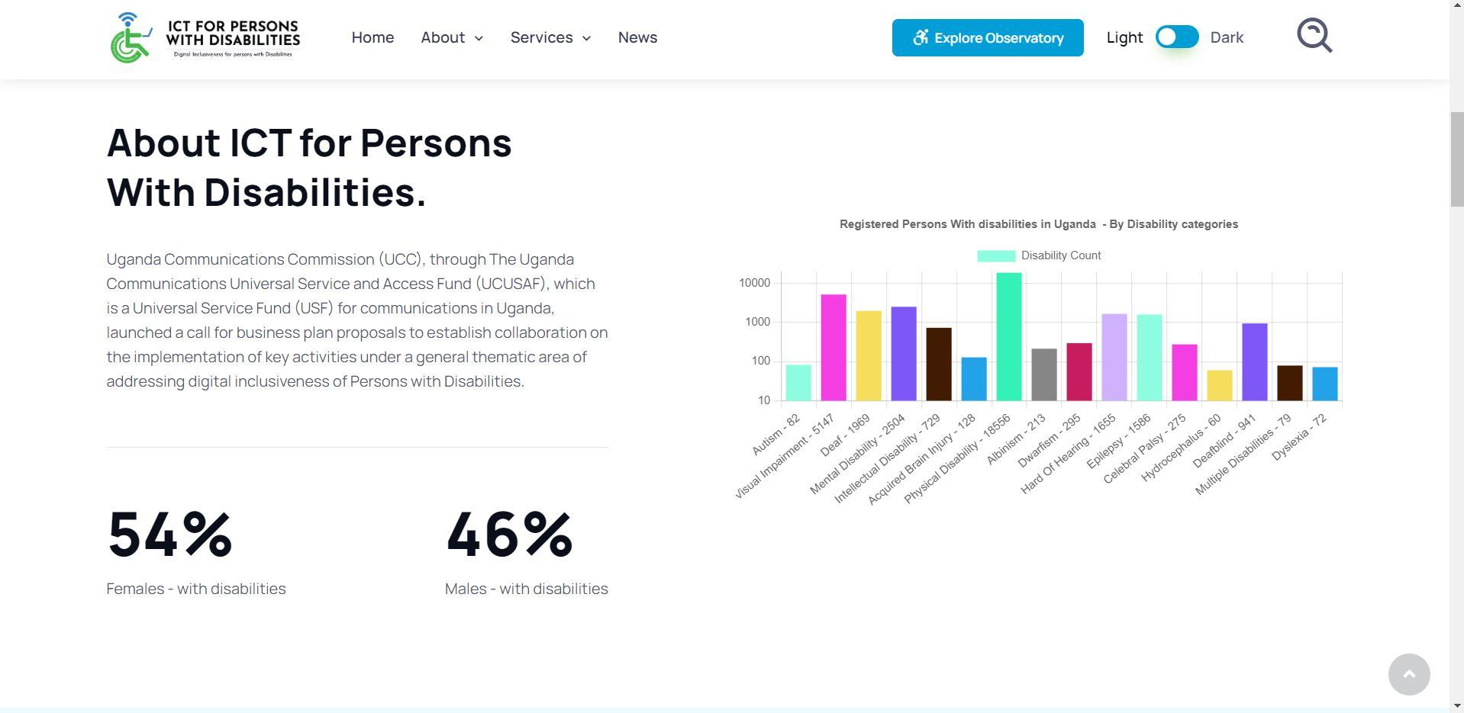

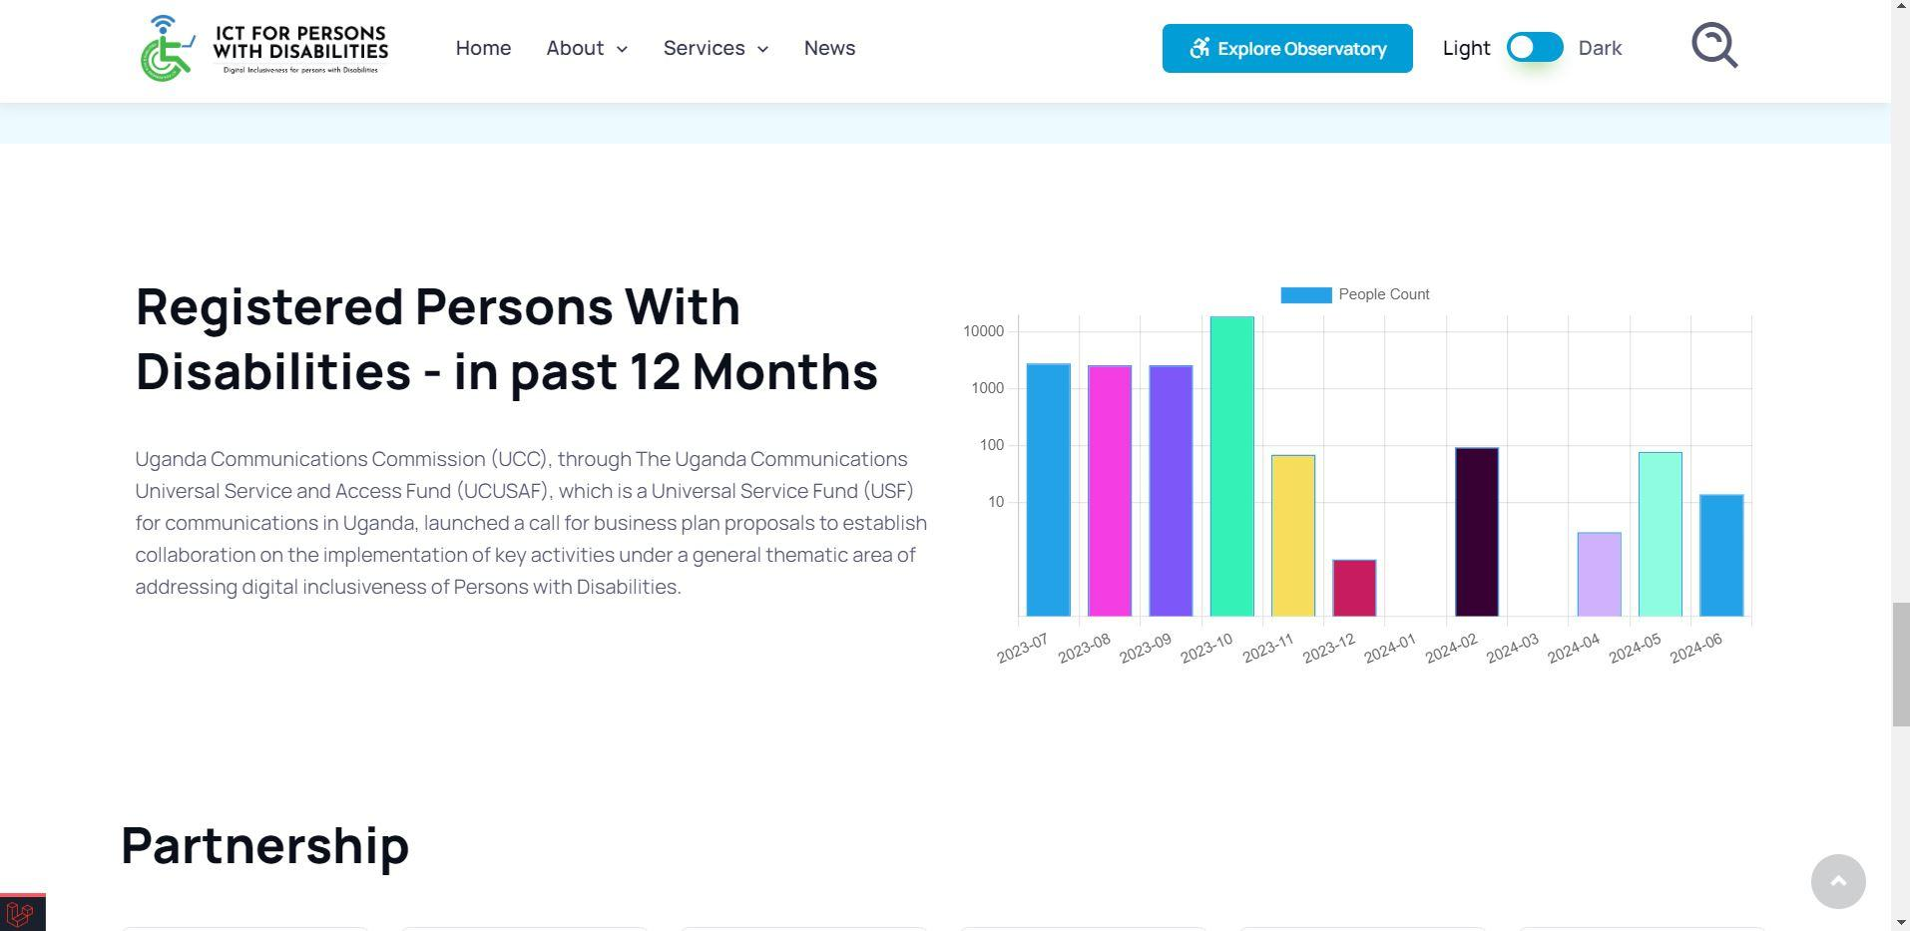

***The home Page***

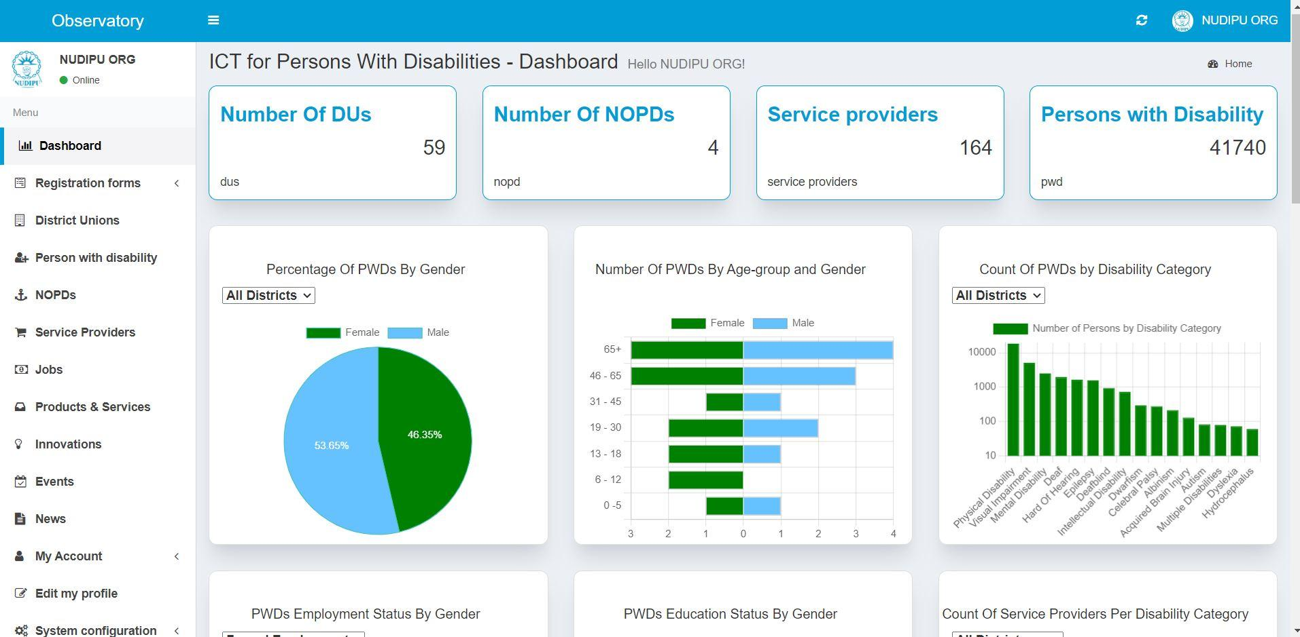

***Administrator Dashboard***

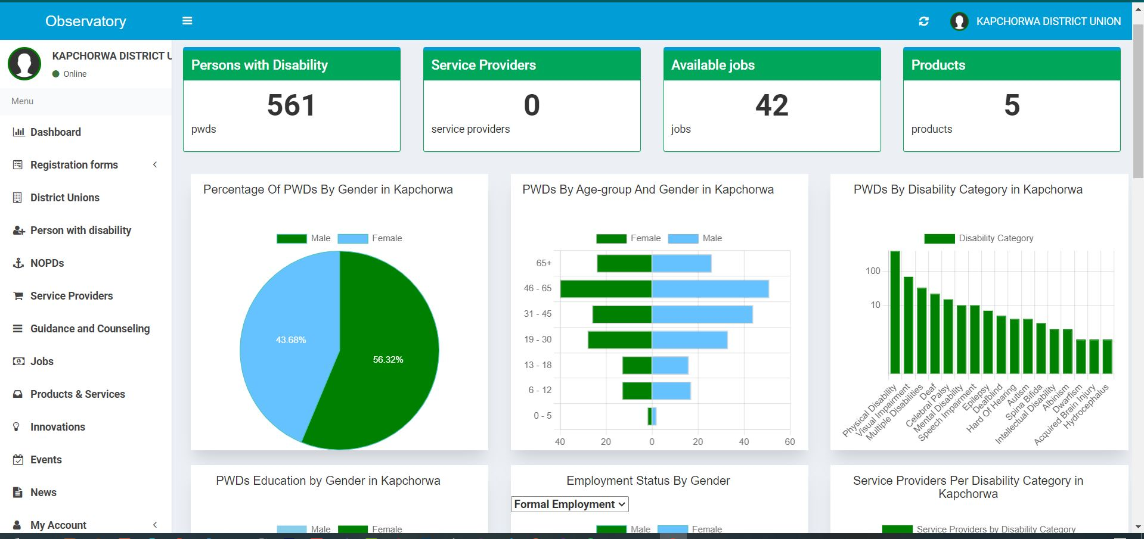

***District Union dashboard***

We changed the person data capture (profiling) and organisation registration to a single page in order to save time and over-clicking to the next page, as shown in the screenshots below.

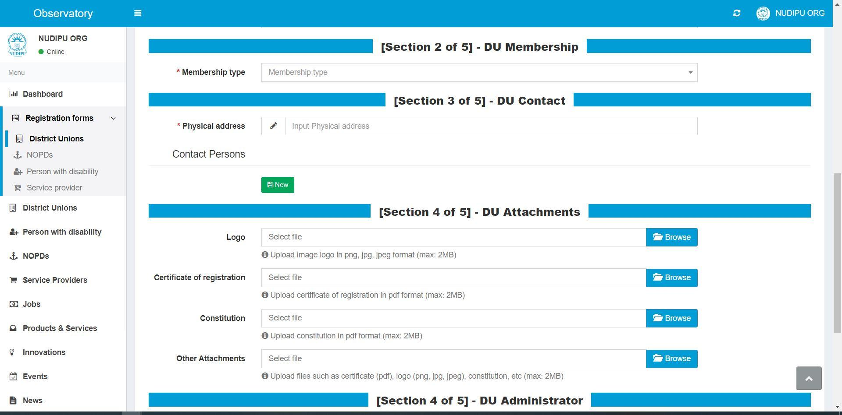

***District Union Registration***

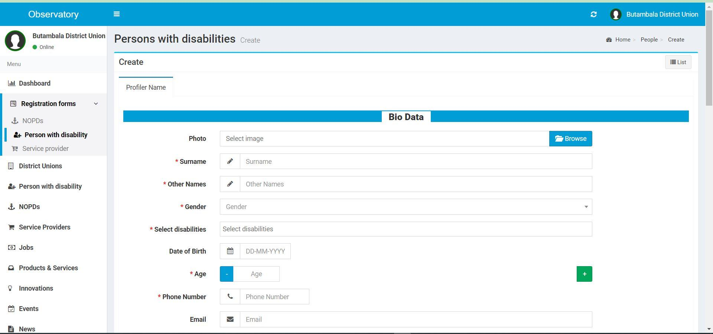

***Person registration***

**THE DIGITAL OBSERVATORY MOBILE APP.**

The mobile app is designed for both android and iOS smartphone users but it is still undergoing integrations that will yield a simple and user-friendly interface.

|  |  |
| --- | --- |
| Welcome Page | Home Page |

|  |  |
| --- | --- |
| *Service providers list* | *Jobs and Opprotunities* |